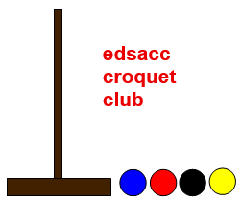
EDSACC CROQUET CLUB
Host Club for CNSW Inc.
Golf Singles and Doubles
DIVISION 2 CHAMPIONSHIPS 2016
HANDICAPS 5 - 8
Doubles Monday 7th – Tuesday 8th March 2016
Singles Wednesday 9th - Friday 11th March 2016
Entry: Doubles $30 per team Singles $30 pp

Refreshments provided all day
Lunch available for purchase daily

Registration and practice: Sunday 6th March: 2pm to 4pm
Play commences at 9:00am each day

Closing Date: 19th February 2016
To enter online click here for Doubles and here for Singles.

Tournament Manager John Compton email: comptos46@bigpond.com
EDSACC Club Contact Cheryl Patterson email: cheryl_afro@hotmail.com
EDSACC Club phone: 4332 1154

Location: EDSACC Sports Complex, Central Coast Highway, Bateau Bay

(opposite Bay Village Shopping Centre)
Directions: from The Central Coast Highway, turn into Yakalla Street, then immediately turn first right into a car park, drive through the car park, past the oval on left, then turn first left and you will arrive at the Croquet Club.

