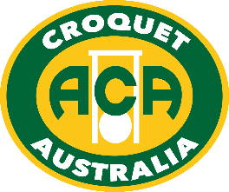

INAUGURAL UNDER 21 GOLF CROQUET CHAMPIONSHIP

Does your grandchild, son, daughter or neighbour play croquet and are under the age of 21?

Croquet Australia is holding its inaugural Under 21 Golf Croquet Championship during January at the Maitland Croquet Club in the Hunter Valley.

Play will be over three days from Friday 15 to Sunday 17 January, 2016. With only thirteen months to go before Australia hosts the World Under 21 Championship this tournament heralds the launch of the Australian Under 21 Squad.

Entry to the event is free.

Croquet Australia is providing financial assistance of up to $100 for each Player and those attending from outside of Maitland requiring accommodation can contact the National Director of Under 21 Croquet, Jacky McDonald, by email ndu21c@croquet-australia.com.au or call 0409 246 294.

Competitors under the Age of 18 will need to provide written consent. Once a registration has been received the required forms will be emailed.

To enter follow the link to
The Duffers Tice http://www.thedufferstice.com/tournaments-by-category/gc/croquet-australia. The event is a unique opportunity to hone skills against players of similar age and experience.

The format will be a round robin and the rules of Golf Croquet will be used and they are available on the Croquet Australia website.

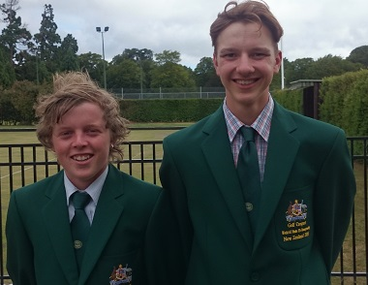

Jack Williams (VIC) Ned Wilson (SA)
Represented Australia in the
World Under 21 World Championship held in New Zealand during February 2016

www.croquet-australia.com.au

Inaugural Under 21 Golf Croquet Championship

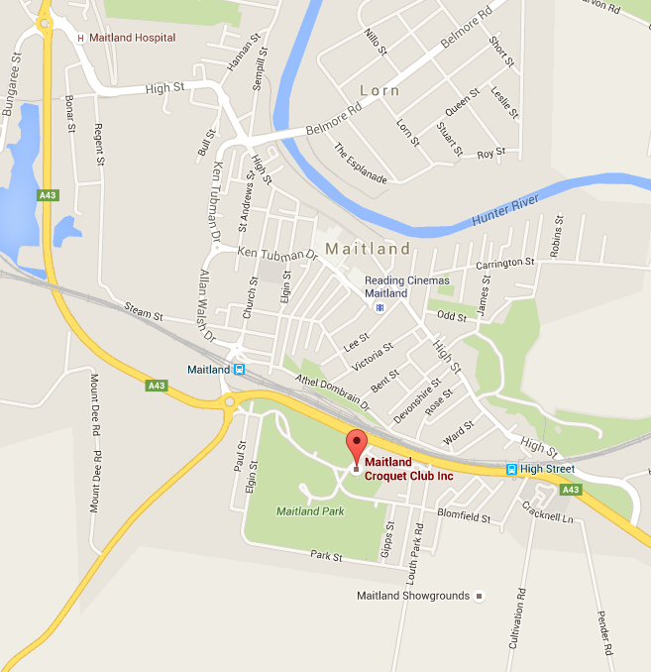

Venue Maitland Croquet Club, NSW

Entry Fee Free

Dates Friday 17 to Sunday 19 January, 2016

Tournament Manager Peter Smith

Tournament Referee Bev Smith

Under 21 Coach Terry Ericson

Student Liaison Jacky McDonald

The Winner will receive the Inaugural Under 21 Golf Croquet Championship Gold Medal and a Peter Coles’ PFC Hoop Maker Mallet made to their specifications (Value approx. AUD $450.00)

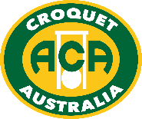

www.croquet-australia.com.au

