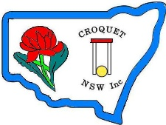
Croquet NSW
GOLF CROQUET (DIVISION 2)
CHAMPIONSHIPS - 2017
DOUBLES and SINGLES
(Handicaps 5 to 8)
Doubles Monday 27th – Tuesday 28th March 2017
Singles Wednesday 29th - Friday 31st March 2017
To be held at CNSW Headquarters, Mackey Park (map etc)

Entry: Doubles $30 per team Singles $30 pp

Entries via Duffers Tice (click here for doubles, here for singles)
or download entry form & email/post to CNSW
For accommodation suggestions click here.
Lunch available from a nearby cafe. They will deliver our phone orders.
Tea & Coffee available all day

Entries close Friday 17th March, 2017

