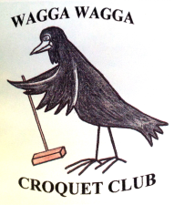
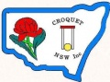
CROQUET NSW
Golf Croquet Championships
Hosted by: Wagga Wagga Croquet Club

Doubles Handicap
Thursday 21st September to Friday 22nd September 2017
Entry Fee: $30/Team
Includes Morning and Afternoon Teas

Singles Handicap
Saturday 23rd September to Sunday 24th September 2017
Entry Fee: $30/Player
Includes Morning and Afternoon Teas

Closing Date: 4th September 2017
To enter online click here for Doubles and here for Singles.

Practice Available Wednesday 20th September from 3pm

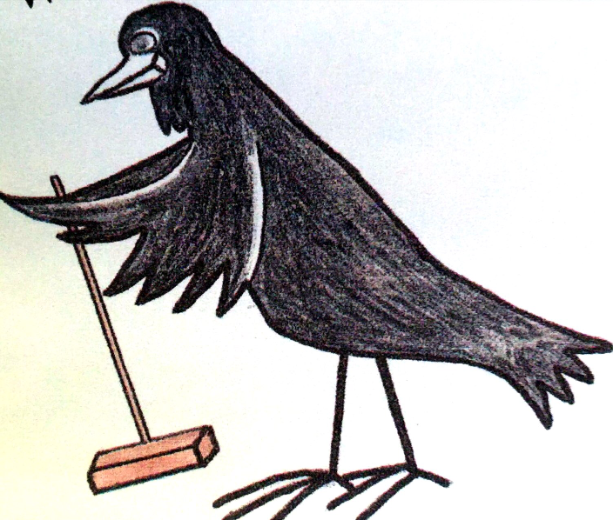
Wagga Wagga Croquet Club

Fitzhardinge Street, Wagga Wagga
PO Box 1038 Wagga Wagga NSW 2650
e-mail: secretary@waggacroquetclub.org
Phone: 02 69 225754

