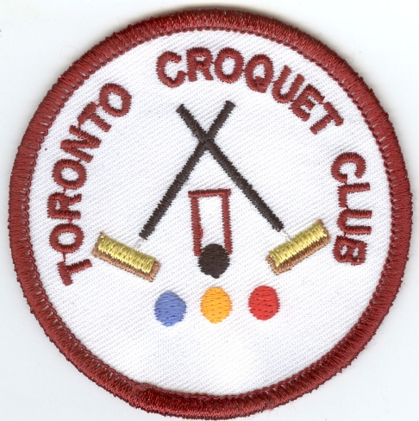
Toronto Croquet Club &
Lake Macquarie City Council
presents
LAKE MACQUARIE GAMES

GOLF CROQUET DOUBLES/SINGLES
Monday-Tuesday 21-22 November 2016
RICOCHET DOUBLES
Wednesday 23 November 2016
(Closing Date for all entries Friday 21 October 2016)

Registration 8:00 Play starts 8:30

- GOLF CROQUET –Level seeded block play. Handicap cards must be used.
- Players may nominate in pairs, or singly and be partnered with someone.
- A limit of 8 players per club may need to be applied. Whilst preference will be given to those players who entered our cancelled July event, all interested players are encouraged to register their interest early.

- RICOCHET- Format to be advised once entry numbers are confirmed. 1.5 hour games.
- Handicaps (GC equivalent) will be used.
- A limit of four players per club may need to be applied.
- Players may nominate in pairs, or singly and be partnered with someone.

- ENTRY FEE- GC: $15.00 per person- morning and afternoon teas included
- ENTRY FEE- RICOCHET: $10.00 per person- morning and afternoon teas included

Informal evening dinners may be organized, depending upon the level of interest.
Lunch may be ordered at Club.

Entries to Secretary, Toronto Croquet Club, PO Box 369 TORONTO NSW 2283
Enquiries: Nerida Taylor 4975 3739 or Kevin Davies 4959 2300

Name: | Ricochet: Yes No
GC Singles: Yes No | GC Doubles Yes No
GC Partner’s Name: | Ricochet Partner’s Name
Address or Email:
Mobile Phone: |  | Phone:
Club: |  | GC Handicap: Index:
Referees: Would you be willing to assist Yes / No
Visit our web site at https://sites.google.com/site/torontocroquetclub/home

