JAMBEROO CROQUET CLUB Inc

Keith Irvine Oval, Churchill Street, Jamberoo

Golf Croquet tournament

Singles & Doubles



Handicap play

Tuesday 4th April to Friday 7th April, 2017

|  |  |
| --- | --- |
| 32 players  Everyone plays 7 Singles and 7 Doubles games Partners will be allocated by the Tournament Manager. Initially, there will be a limit of 6 players from the same club. | $50 per person  Includes tea, coffee and light refreshments daily. Lunch may be purchased at the clubhouse – Please order before 10 am – |

*DON’T DELAY – BOOK TODAY!*

Registration and Practice on Monday 3rd April from 2 pm

If the weather is suitable, we will have an informal dinner at the lawns on Monday evening - Cost $10 per person - pay on the night.

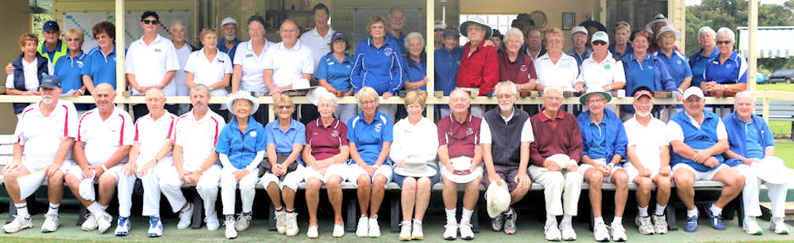

Players and Helpers in 2016

Tournament Manager

Judy McCumstie

1/27 Railway Ave, Minnamurra, NSW 2533

Phone : 4237-7134 0419-957949

[judymccumstie2@gmail.com](mailto:judymccumstie2@gmail.com)

NOTE : To register for this tournament, first, check for vacancies and then you have a choice of 2 options for payment:

1. Pay your **$50** entry fee by **direct debit** to the Jamberoo Croquet Club Account

BSB 032 689

Account number 111 857.

Email a copy of the transaction, together with your completed entry form to [judymccumstie2@gmail.com](mailto:judymccumstie2@gmail.com)

OR

1. Post your completed entry form and **cheque / money order** (payable to Jamberoo Croquet Club Inc) for **$50** entry fee to:

The Tournament Manager

Jamberoo Croquet Club Inc

1/27 Railway Ave

Minnamurra NSW 2533



JAMBEROO CROQUET CLUB Inc

2017 Golf Croquet Handicap Tournament

Singles and Doubles

Tuesday 4th April to Friday 7th April 2017

|  |  |  |  |  |  |  |  |  |  |  |  |
| --- | --- | --- | --- | --- | --- | --- | --- | --- | --- | --- | --- |
| Name |  | | | | | | | | | | |
| Address |  | | | | | | | | | | |
| Phones |  | | | | |  | | | | | |
| E-mail address |  | | | | | | | | | | |
| Club |  | | | | | | | | | | |
| Handicap |  | | Index |  | | | | ACA ID | |  | |
| Method of Payment | | Cash | | | Cheque | | | | Bank Transfer | | |
| Are you willing to referee one game a day? | | | | | | | Yes | | | | No |

NOTE: This form can be completed on-line. Just click in each box and start typing! There is no need to print it, fill it in and then scan it (but you can, if you want to do it the hard way)!