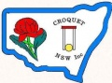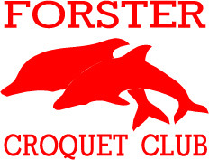

FORSTER CROQUET CLUB

HOST CLUB FOR 2018

NSW GOLF CROQUET HANDICAP

CHAMPIONSHIPS

Doubles: Weds 19th & Thurs 20th Sept 2018

Entry Fee : $35.00 per team

Singles: Fri 21st, Sat 22nd & Sun 23rd Sept 2018

Entry Fee : $35.00 per player

Morning & afternoon tea provided

Lunch available for purchase daily

Lawns available for practice from 1:00pm to 4:00pm Tues 18th

Closing date for entries: 7th September 2018

Registration on CNSW Entry form

or from CNSW website Events page

Forster Croquet Club Club Contact: Fred Smith-White

Lake Street em25109@bigpond.net.au

Forster NSW 2428 0458 447 269