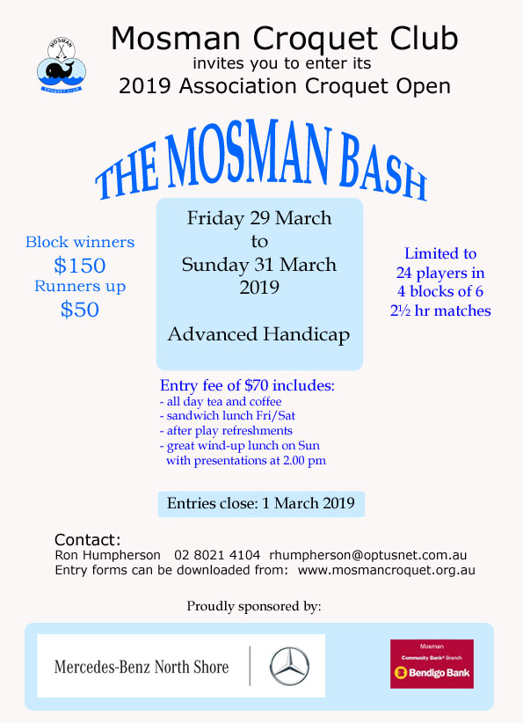

| ENTRY FORM The Mosman BASH FOR ASSOCIATION Croquet  29 – 31 MARCH 2019 | | | |
| --- | --- | --- | --- |
| entries close: 14 MARCH 2019 | | | |
| PLAYER Information | | | |
| Name: | | | |
| CNSW ID: | | Club: | |
| AHS Handicap: | | Are you willing to referee: Yes No | |
| Home Telephone: | | Mobile: | |
| E-mail: | | | |
| Postal Address (if no email address): | | | |
| FEES | | | |
| Entry fee includes: all day tea/coffee and cakes, sandwich lunch Fri/Sat, after play refreshments and **wind-up lunch on Sunday**. Visitors welcome at Sunday lunch. | | | |
| Entry fee: | | | $70 |
| Sunday lunch @ $15 (non-players) | No of visitors | | $ |
| Total | | | $ |
| PAYMENT INFORMATION | | | |
| I will be paying by:  Post: On-line: | | | |
| Send this form with your cheque to:  Tournament Manager,  The Mosman Prize for Golf Croquet  Mosman Croquet Club,  Alexander Ave, MOSMAN, 2088 | | Pay by direct deposit to CBA Mosman:  BSB 062-207 Account No. 00900232  Ref: MB “your name”  Send a copy of this form by email to: [rhumpherson@optusnet.com.au](mailto:rhumpherson@optusnet.com.au) | |
| for more information | | | |
| Tournament Manager: Ron Humpherson Tel: 02 8021 4104Mosman Croquet Club Website: www.mosmancroquet.org.au | | | |