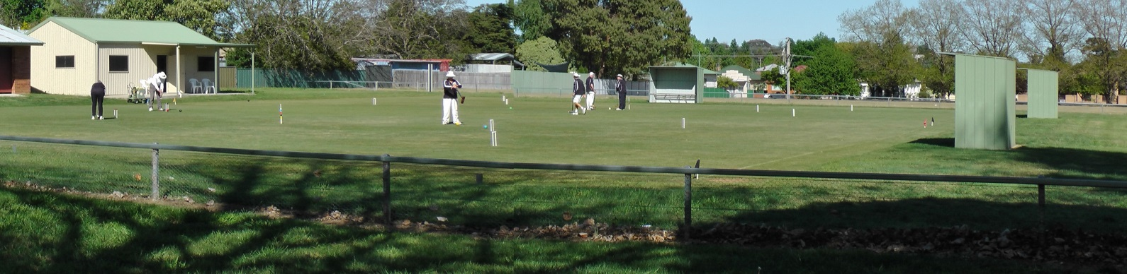

Orange City Croquet Club
Association Croquet Autumn Carnival
Handicap Doubles and Singles
Monday March 25th – Friday 29th 2019
Jaeger Reserve,
149 Hill Street Orange

Entries:
- Maximum 21 players Singles (3x7players blocks)
- Dependent on entries may either be level or handicap play.
- Entries accepted strictly in order of receipt of entry and payment
- Final format dependant on number of entries

Entry Fee:
- $50.00 per player
- Closing date: March 15th 2019

Practice and Registration:
- Sunday March 24th 2:00 to 4:30

Catering:
- Morning and Afternoon tea provided
- Lunches may be ordered on the day
- Carnival Dinner Wednesday March 27th venue TBA

Further Information Contact:
Tournament Secretary | Rik Mills | 04 3994 8198 / 02 6362 5592
Email: | orangecroquet@gmail.com
Postal Address: | Orange City Croquet Club, PO Box 8579, Orange East, NSW, 2800

ORANGE CITY CROQUET CLUB
ASSOCIATION CARNIVAL 2019
Entry Fee: $50per person
Name:
Address:
Phone: | Email:
Club: | ACA ID:
Handicap: | Index:
Please make cheques payable to Orange City Croquet Club or
Direct Transfer to Orange City Croquet Club Inc. BSB: 802-129 A/C No. 43313.
Ensure you identify the transfer with your name and send an email notification of transfer to orangecroquet@gmail.com
I CAN ASSIST WITH REFEREEING YES /NO

ORANGE CITY CROQUET CLUB
ASSOCIATION CARNIVAL 2019
Entry Fee: $50 per person
Name:
Address:
Phone: | Email:
Club: | ACA ID:
Handicap: | Index:
Please make cheques payable to Orange City Croquet Club or
Direct Transfer to Orange City Croquet Club Inc. BSB: 802-129 A/C No. 43313.
Ensure you identify the transfer with your name and send an email notification of transfer to orangecroquet@gmail.com
I CAN ASSIST WITH REFEREEING YES /NO

