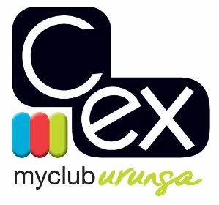

URUNGA CROQUET CLUB

11th ANNUAL GOLF CROQUET SINGLES CARNIVAL

Tuesday 20th to Friday 23rd October 2020

Round Robin Event with Level and Handicap Play

ENTRY FEE: $45.00

Entries restricted to up to 6 members from any one Club and will be accepted on the basis of the first received with payment.

Practice from 1 PM Monday

All entries to:

October GC Carnival Secretary
C.ex Urunga Croquet Club
PO Box 95
Urunga
NSW 2455

C.ex URUNGA CROQUET CLUB

ENTRY FORM for Golf Croquet Singles Carnival

Tuesday 20th to Friday 23rd October 2020

Name:
Address:
Phone No:
Mobile No:
Email Address:
Club
Golf Croquet Handicap

Are you willing to assist with refereeing? YES / NO

Are you a qualified Golf Croquet Referee? YES / NO

Entries restricted to up to 6 members from any one Club and will be accepted in strict order of payment.

Cost: $45.00

All entries to: October GC Carnival Secretary Electronic Payment:
Urunga Croquet Club Account Name: Urunga Croquet Club
PO Box 95 BSB: 533-000
Urunga Account Number: 50338
NSW 2455 Details: Surname GC Oct

