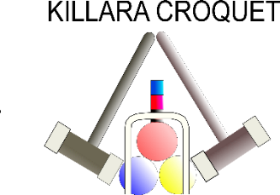

CNSW
ASSOCIATION CROQUET
BRONZE SINGLES TOURNAMENT
2021

Open to Handicaps 14-20
18 point games
Ordinary Level Play
Games will be double-banked
2 hrs. time limit per game
Starting time each day will be advised when the number of entries is known

Morning tea, and all-day tea and coffee will be provided.
Killara Croquet Club is a 10-15 min. walk, uphill, from Killara Station.
Parking is available in Lorne Avenue (with some time restrictions), also in Killara Station Carpark ($5 per day) or in Spencer Road.

