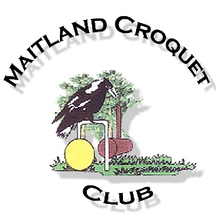
Don’t Miss…….
Maitland Croquet Club
And
Croquet New South Wales’
Golf Croquet
Bronze Brooch
Handicaps 7 to 10
to be held at
Maitland’s Croquet Lawns
From Monday 9th to Wednesday 11th August, 2021.

Bronze Brooch Details…..
This event is open to all CNSW GC players with a handicap in the 7-10 range. It is a singles event involving level play.
Games will begin at 8:30 am and may continue into the dark as we have 4 fully lit lawns. It will be in all our interests if games are played with due dispatch.
Lawns will be open for practice from 2:00pm to 4:30pm Sunday 8th August for early registration and practice.
Each day a 20 min practice session will be held starting at 7:50 am. A short meeting of all players and officials.will be held each day, at 8:10am immediately prior to the start of play
Meals will not be available but a donation of a gold coin will ensure that a bottomless cup of tea or coffee will always be available to help wash down some of the tasty little treats some of our members love to make for us all.
DON”T forget to bring your handicap card (make sure you go on line and match your card with your CNSW record) and make sure that your current level of performance matches your handicap. If there is a discrepency consult with your club’s handicapper or consult our event handicapper.(who may adjust your H/C in view of your performance.
At the conclusion of each game ensure you update your Automatic Handicap Scoring system card. If, during play, you TRIGGER (Either up or down) take your card to the Tournament Director or Event Handicapper.
Club phone number =49330092 Tournament Manager= 0411 240 740
The Internet reveals a range of accommodation available within a short disance of our lawns. Travel through the CBD in early morning may present some minor time difficulties.
To Register Go to “CNSW” web site. Click “EVENTS”. In the line for “CNSW EVENTS” click on the last entry “2021” Scroll till you find Aug
“Mon 9th – Wed 11th. GC. BRONZE BROOCH” and click on red “Register”.
Follow prompts
OR
“Sign In” on CNSW Home Page. Then select “Event Registration” and follow prompts.

Best Wishes…. Peter

