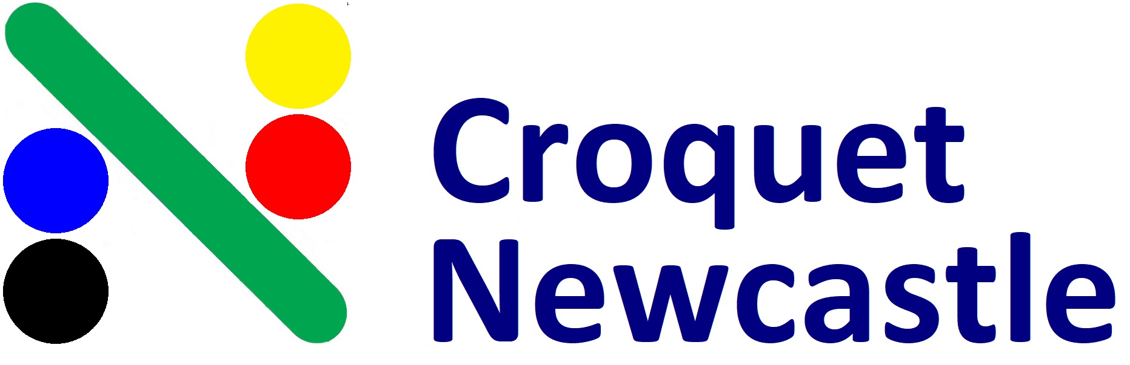
___________________________________________________________________________________

Association Singles Carnival
8th & 9th May 2021

____________________________________________________________________________________

SINGLES: Saturday/Sunday 8th & 9th May
Level play intended, but Handicap play may be necessary. Please indicate your preference. 2.5 hour games. May be double banked.

____________________________________________________________________________________

Entry Fees: $30/person
Tea, coffee and light refreshments will be provided, and lunches on Saturday and Sunday are available for purchase at the clubhouse.
____________________________________________________________________________________

Entries and payment by Friday 30th April 2021. Please email your name, club name, handicap, index, phone number and whether you are willing to referee to: croquetnewcastle@gmail.com with the Subject line: “AC Carnival Entry”
Direct Debit: BSB 650000 A/C No. 952962418 Details: AC + your surname OR
mail with cheque (payable to Newcastle National Park Croquet Club) by 30th April to: Secretary, PO Box 2052, Dangar, NSW, 2309.
(a $10 processing fee will be deducted if a refund cheque is required)

Tournament Manager – Larry Bryant 0418 650 210 Games Captain – Derek Bull 0417 565 475
Newcastle National Park Croquet Club - 25 National Park Street, Newcastle West, NSW, 2302
____________________________________________________________________________________

