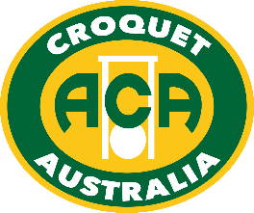

Australian Association Croquet
2023
Australian Ricochet
Singles & Doubles
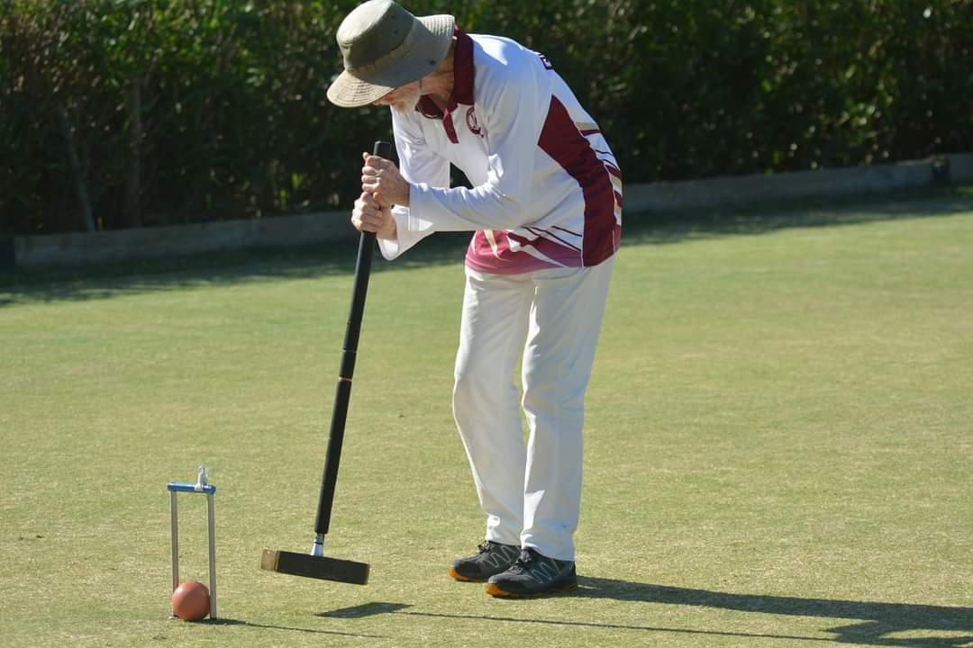
In 2023, the inaugural Australian Ricochet Croquet Open Singles & Doubles Championships are being held at the New South Wales Croquet Centre, Mackey Park, Tempe. Seasoned competitors, and those new to the competition scene, are equally welcome.

The Australian Croquet Association welcomes Parbery Consulting, major sponsor of the Australian Ricochet Croquet Championships (click here for more info about Parbery – https://www.parbery.com.au/about-us/). ACA’s partnership with Parbery provides $800 worth of cash prizes available across the events, distributed to places 1-4 for the Singles, and to places 1-4 in the Doubles.
Proudly Sponsored by

Australian Ricochet Croquet – 2023 Open Singles & Doubles Championships
The Doubles Championship will be on Friday 14th April - Sunday 16th April
The Singles Championship will be on Monday 17th April - Thursday 20th April
Headquarters: New South Wales Croquet Centre Mackey Park Tempe NSW
Prizes & Trophies: The Singles Winner will be presented with the Perpetual Ricochet Plate, and cash prizes will be awarded to places 1 through to 4.
The Doubles Winners will receive the ACA Perpetual Trophies,
and cash prizes will go to the first 4 placing pairs.
Catering: Coffee & tea free; lunch & other food/drink available for purchase from Concordia Club on Friday-Sunday. BYO food on other days.
Closing Date for Entries: Friday 24 March 2023 (midnight WA time).
Entry Fees - Doubles: $50 per player
Entry Fees – Singles: $90 per player
Full time students (under 25), and players aged under 21 at 31 Dec 2022, are entitled to a 50% reduction of the above fees.
How to Enter - Doubles: https://croquet-australia.com.au/rc-open-doubles/
You can nominate a Doubles partner in the entry, or just put
“Need a Partner” in the box and we will find you one.
How to Enter - Singles: https://croquet-australia.com.au/rc-open-singles/
If you get an error message, don’t re-do your entry. Events will be in touch with confirmation that you’ve entered (also keep an eye on “Entries” under these events on croquetscores).
Format – Doubles: Format will depend on the actual numbers of entrants, but the Doubles is expected to be played as blocks initially and followed by knockout rounds with best-of-3 final. Doubles will be played over 3 days.
Format – Singles: Format will depend on the actual numbers of entries but the Singles is expected to start with blocks followed by knockout rounds with a best-of-3 final. Singles will be played over 4 days.
Note – Players must be prepared to play up to three games a day. All games are likely to be double banked, except semi-finals and the final (if lawn availability allows).
Draw: To be conducted by the ACA Events Committee with help from the Ricochet National Co-Ordinator, using the ACA Seeding and Draw procedures. The latest available ricochet handicap at the entry closing date will be used for seeding purposes.

www.croquet-australia.com.au

