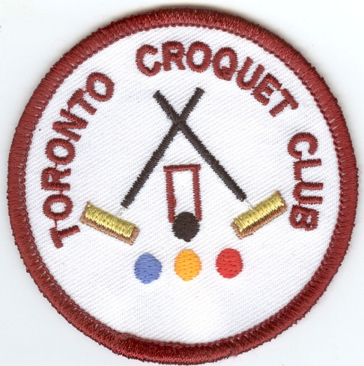
Toronto Croquet Club &
Lake Macquarie City Council
presents

LAKE MACQUARIE GAMES
GOLF CROQUET DOUBLES CARNIVAL
Friday 6 November 2015
(Closing Date 23 October 2015)

Registration 8:00 Play starts 8:30

- Level Play
- Players may nominate in pairs or singly, and be partnered with someone.
- Limit of 8 players per club
$15 per person (includes morning and afternoon tea)
Lunch can be ordered on the day

Enquiries: Pam Wiemers Games Captain 4945 0434 or Kevin Davies 4959 2300

Name:
Address or Email
Mobile Phone: | Phone:
Club: | Handicap: Index:
Referees: Would you be willing to assist Yes / No

Name:
Address or Email
Mobile Phone: | Phone:
Club: | Handicap: Index:
Referees: Would you be willing to assist Yes / No

Visit our web site at https://sites.google.com/site/torontocroquetclub/home

Entries to: Secretary Toronto Croquet Club PO Box 369 Toronto NSW 2283 or torontocroquetclub@yahoo.com.au

