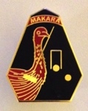
MAKARA 2017

In 2017, the MAKARA Croquet Carnival began with the Silver Singles event on Wednesday 25 October. The event was hosted by Marrickville Club and the winner was Charles Britton (Marrickville).

On October 30 & 31, Port Hacking Club hosted the Ricochet Handicap Doubles event. It is difficult to imagine two days with more contrasting weather conditions. Day 1 - temperatures around 35 Deg C then gale-force winds in the late afternoon; Day 2 - very cool morning requiring warm jackets followed by a sunny but still somewhat windy day. Seven teams representing 5 different croquet clubs competed in the event and used the new CNSW Ricochet Handicap Cards to record results. Games were closely contested with many results only different by 1 or 2 points. Everyone agreed the handicap play had added some "spice" to the competition and left eager for more RC competition.
Winners were Cheryl Patterson (EDSAAC) and Chris Williamson (Toronto) and runners-up were Andrew Kelly and Wal Fernance (Sutherland).

Next in the 2017 MAKARA suite of events was the Bronze Singles, hosted by Strathfield Club on November 4 & 5. Winner of the event - and the Wilson trophy - was Yvonne Webster (Strathfield) with Maria Morton (Warrawee) as runner-up.

The first GC event was the GC Handicap Singles hosted by Coogee Club on November 8 & 9. Winner of the event - and the Fernance trophy - was Dianne Bonnitcha (Sutherland) with Ros Johnstone (Sutherland) runner-up.

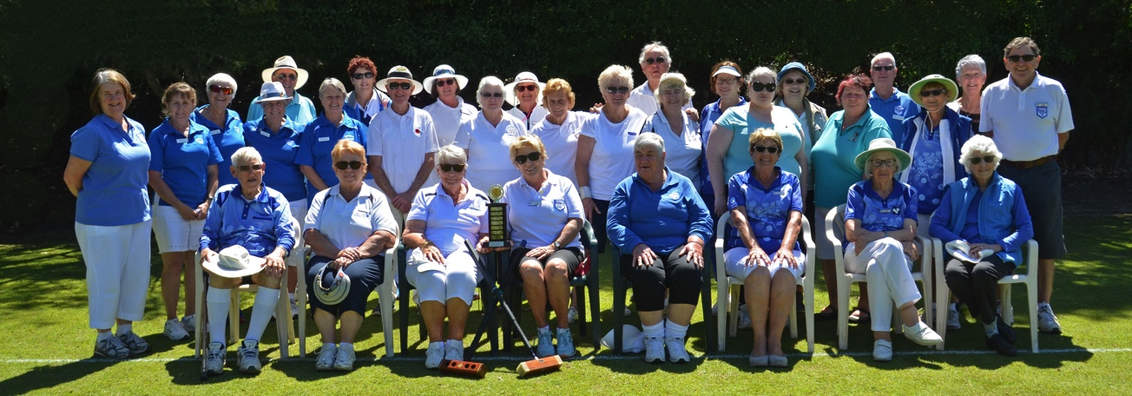

The final event in MAKARA 2017 was the GC Handicap Doubles, hosted by Sutherland Club and held on November 11 & 12. After some fiercely contested block play, the final was between Block "M" winners Janett Midgley and Jill Sullivan (from Sutherland and right of the trophy in the photo) and Block "K" winners Lenora Everton and Maureen Waters (from Wollongong and seated left of the trophy in the photo).
Winners of the final - and the Harry Taylor trophy - were the team from Wollongong.

Thank you to all the players who entered events and to everyone who supported their opportunity to compete by managing, refereeing, preparing lawns and facilities and catering.

Everyone involved can be very proud of the team effort that made MAKARA 2017 such a success!

Lorraine Hatfield
Secretary, MAKARA Committee

