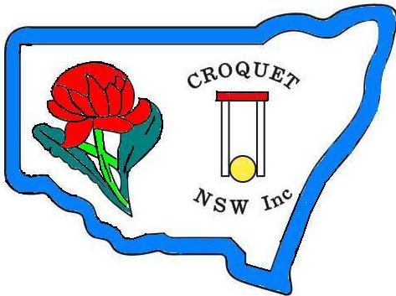
CNSW Invites Members, their Guests and Trophy Winners
to the
2016 Annual Lunch and
Presentation of Trophies

To be held on Saturday 10th December 2016 at the
Club Willoughby
26 Crabbes Ave North Willoughby 2068

Commencing at 11.00am
The luncheon will cost $40

Please notify CNSW of any special dietary requirements

Please send acceptances to Wendy Fothergill at wfotherg@bigpond.net.au copy to office@croquet-nsw.org as soon as possible but no later than 30th November, 2015. Please make your payment by cheque or bank transfer to the Croquet NSW office
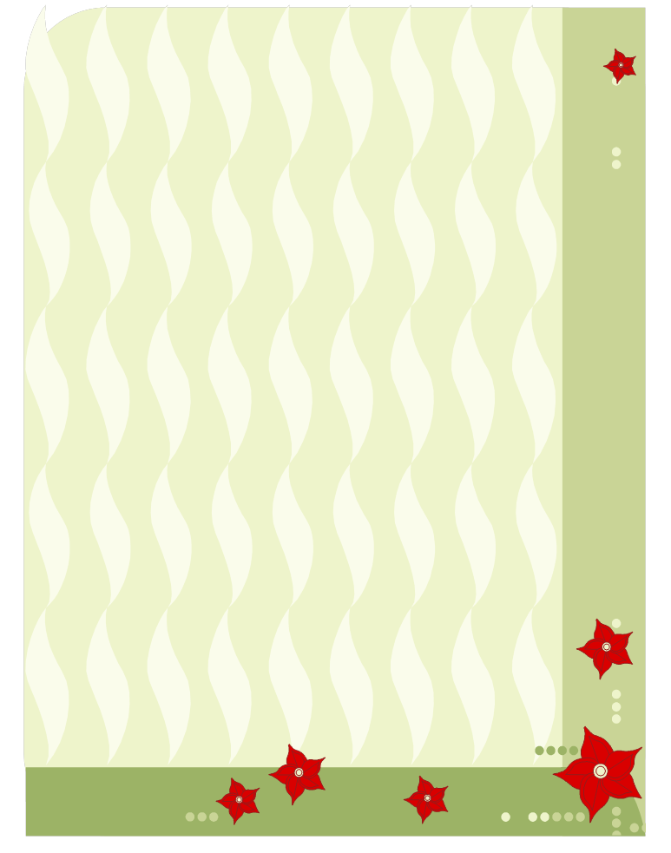

Menu

Atlantic Salmon Fillet
Grilled – with crushed chats and Danish fetta,
young stem broccolini – essence of white truffle oil
or
Corn-fed Chicken Breast
Roasted, with basil mashed potato, baby asparagus
– bacon pancetta and cranberry jus

-------------------------------------------------
Roll and Butter
-------------------------------------------------

White and Dark Chocolate Mousse Cake
with caramel sauce and oranges
or
Passionfruit Cheesecake
with puree of summer berries

The price includes a drink at the bar prior to commencement of the event.

