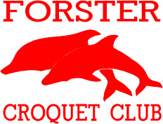
GOLF CROQUET FORSTER
DOUBLES CHALLENGE
3 days of golf croquet
Monday 17th to Wednesday 19th October 2016
Handicap Doubles
Choose your own Partner
Initially, limit 4 players per club
Handicaps 0-10
Entry Fee $35.00 per person
Entries close 26th September 2016
Lunch available each day

Email: forstercroquetclub@gmail.com
ENTRY FORM
FORSTER DOUBLES CHALLENGE
Monday 17th October 2016 to Wednesday 19th October 2016
NAME…………………………………………………………………………………………
ADDRESS……………………………………………………………………………………
TOWN………………………………………………………………………………………..
Home Ph……………………………….Mobile………………………………………..
Email…………………………………………………………………………………………
CLUB…………………………………………………………………………………………
REGISTERED I.D…………HANDICAP…………..PLAYING INDEX………..
This Carnival is a Doubles event.
Can you assist with Refereeing? YES/NO (Accredited? YES/NO
Entry Fee $35.00 per person (Note: entries close 26th September 2016
Email: forstercroquetclub@gmail.com
Send cheques payable to Forster Croquet Club
PO Box 4038, Village Post Office, Forster NSW 2428
Otherwise for bank direct debit our bank details are:
A/C Name: FORSTER CROQUET CLUB – BSB 650 000 No. 517580618
For reference purposes please use your surname.
Please forward your entry form direct to the Forster Croquet Club.

