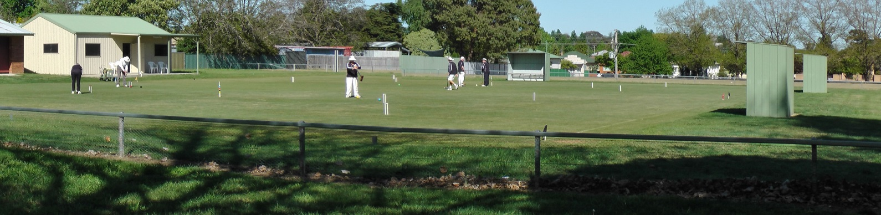
Orange City Croquet Club
Invites you to our
2017 Association Carnival
Monday 27th Feb— Friday 3rd Mar
Jaeger Reserve, Hill St, Orange

Format dependent on entry numbers
Limit of 24 Players
Entry Fee $45.00
Morning and Afternoon Tea provided
Lunches May be Ordered
Carnival Dinner TBA
Entries Close 16^{h} February 2017

Entries to Tournament Secretary:
Rik Mills 02 6362 5592 / 04 3994 8198 orangecroquet@gmail.com
Postal Address: Orange City Croquet Club, PO Box 8579, Orange East, NSW, 2800
Enquiries: Helen James: 0456 634 466

ORANGE CITY CROQUET CLUB
ASSOCIATION CARNIVAL 2017
Entry Fee: $45 per person
Name:
Address:
Phone: | Email:
Club: | ACA ID:
Handicap: | Index:
Please make cheques payable to Orange City Croquet Club or
Direct Transfer to Orange City Croquet Club Inc. BSB: 802-129 A/C No. 43313.
Ensure you identify the transfer with your name and send an email notification of transfer to orangecroquet@gmail.com
I CAN ASSIST WITH REFEREEING YES /NO

ORANGE CITY CROQUET CLUB
ASSOCIATION CARNIVAL 2017
Entry Fee: $45 per person
Name:
Address:
Phone: | Email:
Club: | ACA ID:
Handicap: | Index:
Please make cheques payable to Orange City Croquet Club or
Direct Transfer to Orange City Croquet Club Inc. BSB: 802-129 A/C No. 43313.
Ensure you identify the transfer with your name and send an email notification of transfer to orangecroquet@gmail.com
I CAN ASSIST WITH REFEREEING YES /NO

