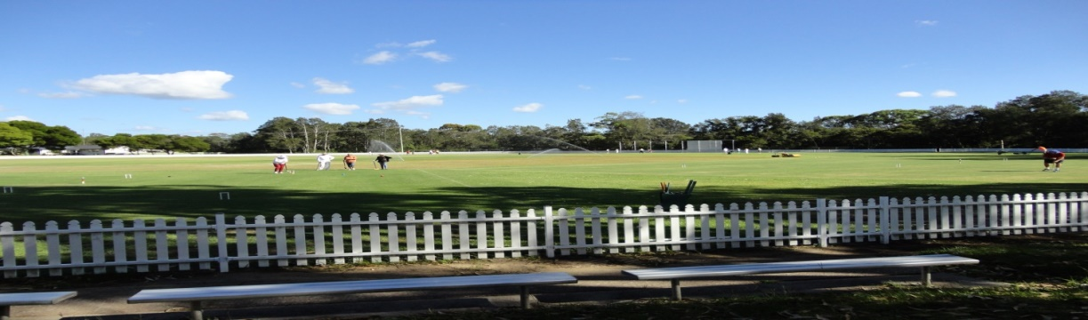
Toronto Croquet Club &
Lake Macquarie City Council present
LAKE MACQUARIE GAMES
GOLF CROQUET
DOUBLES: Monday 4th September, 2017
SINGLES: Tuesday 5th September, 2017
RICOCHET DOUBLES
Wednesday: 6th September, 2017
Closing Date: 18th August, 2017
Registration 8:00 Play starts 8:30
Sandwiches can be purchased each day.
GOLF CROQUET: Level play in seeded block play. Handicap cards will be used.
- Players may nominate in pairs, or singly and be partnered with someone.
- A limit of 6 players per club may be applied.

RICOCHET- Format to be advised once entry numbers are confirmed. 1.5 hour games.
- Handicaps (GC equivalent) will be used to assign blocks
- A limit of four players per club may need to be applied.
- Players may nominate in pairs, or singly and be partnered with someone.

- ENTRY FEE- GC: $15/person Doubles and $15/person Singles - morning and afternoon teas included.
- ENTRY FEE- RICOCHET: $15/person - morning and afternoon teas included.
- Enquiries: Kevin Davies – Ph. 02 49 592300
ENTRY FORM ATTACHED.

LAKE MACQUARIE GAMES:
SEPTEMBER, 2017
NAME:----------------------------------------------------
ADDRESS:_____________________________
_____________________________________
EMAIL: _____________________________________
PHONE:_______________________________
CLUB:_________________________________
HANDICAP_______ INDEX ______________
ENTER CHOSEN EVENT FEES:
GOLF CROQUET ENTRY FEE:
Singles .........
Doubles ……….
RICOCHET ENTRY FEE ……….
I AM/AM NOT ABLE TO ASSIST WITH REFEREEING
Forward to Toronto Croquet Club if payment made by direct debit to
BSB: 637000 Account No 781230863. (Please include your surname & initial)
OR Post to: Tournament Coordinator, PO Box 369 TORONTO 2283; WITH FEE
Please note late withdrawals may not be entitled to a refund of entry fee.

Please use this form for Golf and/or Ricochet Events

PARTNER’S DETAILS:

NAME:----------------------------------------------------
ADDRESS:_____________________________
_____________________________________
EMAIL: _____________________________________
PHONE:_______________________________
CLUB:_________________________________
HANDICAP_______ INDEX ______________
ENTER CHOSEN EVENT FEES:
GOLF CROQUET ENTRY FEE:
Singles ……….
Doubles .........
RICOCHET ENTRY FEE ………..
I AM/AM NOT ABLE TO ASSIST WITH REFEREEING
Forward to Toronto Croquet Club if payment made by direct debit to
BSB: 637000 Account No 781230863. (Please include your surname & initial)
OR Post to: Tournament Coordinator, PO Box 369 TORONTO 2283; WITH FEE
Please note late withdrawals may not be entitled to a refund of entry fee.

