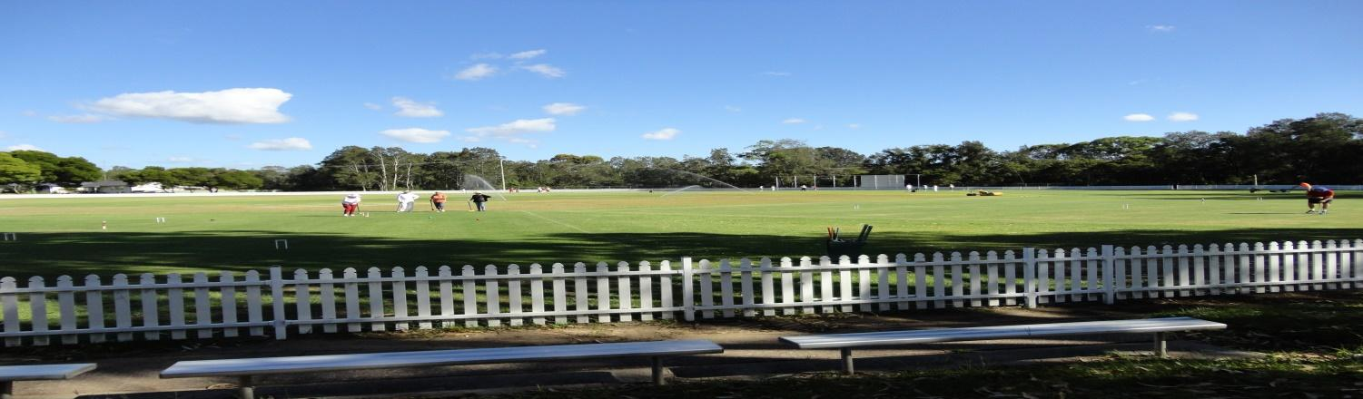
Toronto Croquet Club Inc.
Doubles Gala
Level Play in Blocks Saturday 20/05/17 $20 per player Closing date for applications: Monday 01/05/17
Contacts:
Kevin Davies 49592300
Marie Munns 49530331
Sandwiches can be ordered
Tea/Coffee etc. provided
Entries restricted to six from each club
Entries accepted in strict order with payment
Registration and practice Friday 19/05/17 from 2 pm Games commence 8.30 am Saturday. 8.00 am Registration
Toronto has an extreme weather policy that will be displayed

TORONTO DOUBLES GALA
DATE: 20/05/17

Partner:
NAME:______________________________ NAME:______________________________
ADDRESS:____________________________ ADDRESS:____________________________
_____________________________________ ____________________________________
EMAIL: __________________________________ EMAIL:_____________________________
PHONE:_______________________________ PHONE:______________________________
CLUB:_________________________________ CLUB:________________________________
HANDICAP:________ INDEX ______________ HANDICAP:________INDEX_______________
EVENT FEE: ____________ EVENT FEE:___________

I AM/AM NOT ABLE TO REFEREE I AM/AM NOT ABLE TO REFEREE

Forward to Toronto Croquet Club if payment made by direct debit to
BSB: 637000 Account No 781230863. (Please include your surname & initial)
OR Post to: Tournament Coordinator, PO Box 369 TORONTO 2283 WITH FEE

Please note late withdrawals, may not be entitled to a refund of entry fee.

