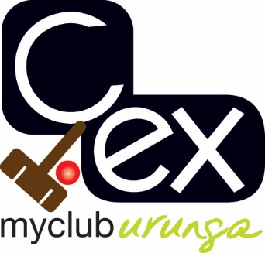

URUNGA CROQUET CLUB

27th Annual association CARNIVAL

16th to 22nd JUNE 2018

Format for 2018 to be determined closer to event and is dependent on entry numbers

HANDICAP RANGE 0 - 20

ENTRY FEE - $50 includes morning and afternoon teas and finger food at presentation

ENQUIRIES TO:

Tournament Manager:
Barb Piggott
02 6655 5085 or 042 762 9953
johnpiggott@bigpond.com

URUNGA CROQUET CLUB

ASSOCIATION CARNIVAL

16 – 22 JUNE 2018

Name:
Address:
Phone No:
Mobile No:
Email:
Club
AHS Handicap

Are you willing to assist with refereeing? YES / NO

Cost: $50.00

All entries to: Association Carnival Secretary Electronic Payment:
Urunga Croquet Club Account Name: Urunga Croquet Club
PO Box 95 BSB: 533-000
Urunga Account Number: 50338
NSW 2455 Details: Surname AC Jun

