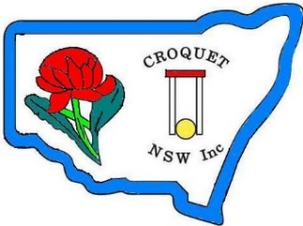
Croquet NSW
Division 1 GC doubles
championships
Hosted by nowra croquet club
Saturday 18th & Sunday 19th August 2018
Bomaderry Sporting Complex
127 Cambewarra Rd Bomaderry
Register via CNSW web page
Cost $17.50 per player

Registration and practice
Friday August 17th 1:30 to 4:30 pm

Lunch available for purchase each day

