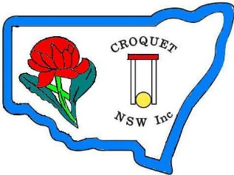
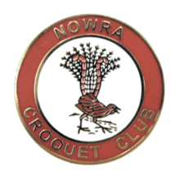
Croquet NSW
Division 1 GC singles
championships
Hosted by nowra croquet club
Monday 20th to Wednesday 22nd August 2018

Bomaderry Sporting Complex,
127 Cambewarra Rd Bomaderry
Register via CNSW web page
Cost $35 per player
Registration and practice
After the doubles finish on the 19th

Lunch available for purchase each day

