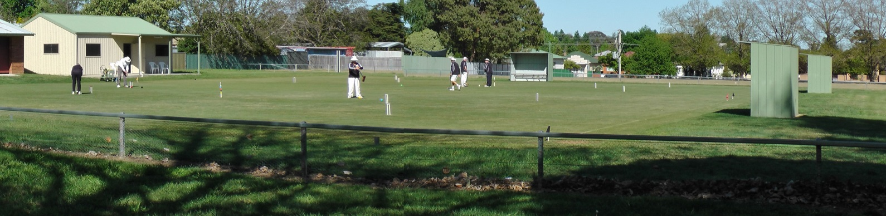

Orange City Croquet Club
Autumn Association Croquet Carnival
Handicap Doubles and Singles
Monday March 12th – Friday 16th 2018
Jaeger Reserve,
149 Hill Street Orange

Entries:
- Maximum 24 players (Singles 3x8 Blocks Double 3 x 4 Blocks, dependent on entries)
- Entries accepted strictly in order of receipt of entry and payment
- An initial limit of 6 players from one club
- Doubles Partners will be allocated
Entry Fee:
- $50.00 per player
- Closing date: March 5th 2018
Practice and Registration:
- Sunday March 11th 2:00 to 4:30
Catering:
- Morning and Afternoon tea provided
- Lunches may be ordered on the day
- Carnival Dinner Wednesday March 18th venue TBA
Further Information Contact:
Tournament Secretary | Rik Mills | 04 3994 8198 / 02 6362 5592
Email: | orangecroquet@gmail.com
Postal Address: | Orange City Croquet Club, PO Box 8579, Orange East, NSW, 2800

ORANGE CITY CROQUET CLUB
ASSOCIATION CARNIVAL 2018
Entry Fee: $50per person
Name:
Address:
Phone: | Email:
Club: | ACA ID:
Handicap: | Index:
Please make cheques payable to Orange City Croquet Club or
Direct Transfer to Orange City Croquet Club Inc. BSB: 802-129 A/C No. 43313.
Ensure you identify the transfer with your name and send an email notification of transfer to orangecroquet@gmail.com
I CAN ASSIST WITH REFEREEING YES /NO

ORANGE CITY CROQUET CLUB
ASSOCIATION CARNIVAL 2018
Entry Fee: $50 per person
Name:
Address:
Phone: | Email:
Club: | ACA ID:
Handicap: | Index:
Please make cheques payable to Orange City Croquet Club or
Direct Transfer to Orange City Croquet Club Inc. BSB: 802-129 A/C No. 43313.
Ensure you identify the transfer with your name and send an email notification of transfer to orangecroquet@gmail.com
I CAN ASSIST WITH REFEREEING YES /NO

