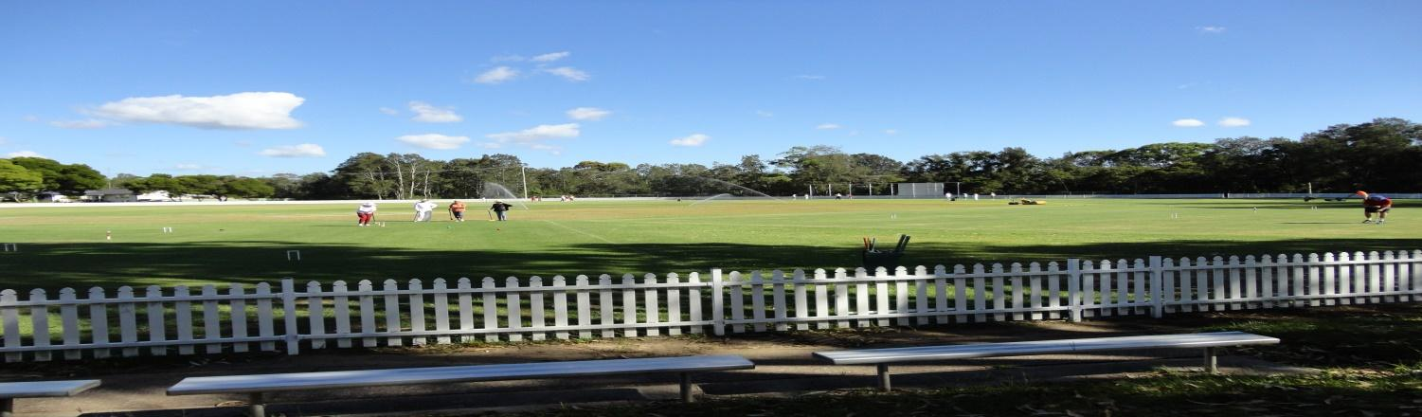
Toronto Croquet Club Inc.
GC Doubles Gala
To be held at Ron Hill Oval, Toronto.
COMPETITION TYPE Level Play in Block
Wednesday 16/05/18 $20 per player
Closing date for applications: Monday 29/04/18
Lunches can be ordered
Tea/Coffee etc. provided
Entries may be restricted to 3 pairs from each club
Entries accepted in strict order with payment
Registration and practice Tuesday 15/05/18: 2pm-4pm
Wednesday- 8.00 am Registration, 8.30amGames commence.
Contacts: (on the day)
Robyn Irwin 0401670123
Janine Burton 0412061437
Toronto has an extreme weather policy that will be displayed.

TORONTO DOUBLES GALA
DATE: 16/05/18
name |  |  | partner name
address |  |  | address
email |  |  | email
phone |  |  | phone
club |  |  | club
Handicap |  |  | Handicap
Index |  |  | Index
Fee$ |  |  | Fee$
Able to referee |  | Y/N | Able to referee |  | Y/N
(please circle)

Please forward registration form to torontocroquetclub@yahoo.com.au
if payment made by direct debit to
BSB: 650 000 Account No 529 487 701. (Please include your surname & initial)

OR Post to: Tournament Coordinator, PO Box 369 TORONTO 2283 WITH FEE
With cheque made payable to Toronto Croquet Club

Please note late withdrawals, may not be entitled to a refund of entry fee.

