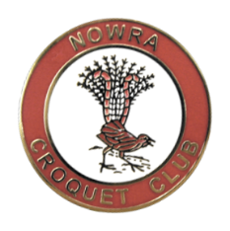
CROQUET NSW

GC Division 3 Championships
Hosted by: Nowra Croquet Club

Division 3 Doubles

Thurs 31st October to Friday 1st Nov 2019 Entry Fee: $35/Team

Division 3 Singles

Saturday 2nd Nov to Monday 4th Nov

Entry Fee: $35/Player

Morning & afternoon tea provided

Lunch available for purchase daily

Closing Date for entries: 17th October 2019 Register online at croquet-nsw.org or submit a CNSW Entry Form.

Practice available Wednesday 30th Oct from 3pm

Nowra Croquet Club

Cambewarra Road Bomaderry

Enquiries: Margaret Sawers Phone: 0417458700 or 02 44215367

