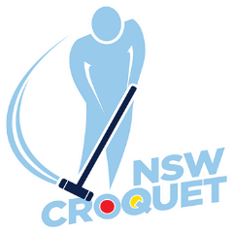
Croquet NSW
Inaugural
golf croquet bronze brooch
Hosted by nowra croquet club
Friday 9th to Sunday 11th August 2019
Bomaderry Sporting Complex
127 Cambewarra Rd Bomaderry
Register via CNSW web page
Cost $35.00 per player
Singles competition Level play, open to
players on handicaps from 7 to 10
Registration and practice
Thursday August 8th 1:30 to 4:30 pm

Morning and afternoon tea gold coin donation
Lunch available for purchase each day

