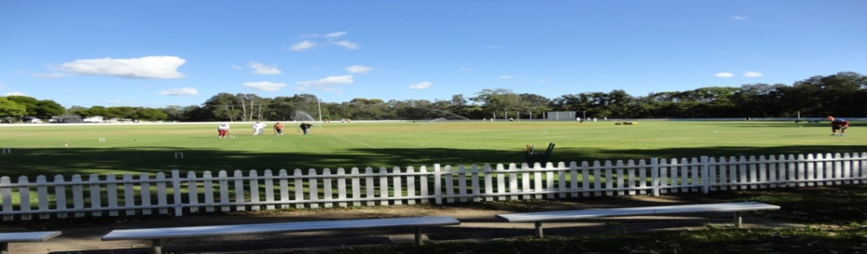
Toronto Croquet Club &Lake Macquarie City Council
present
LAKE MACQUARIE GAMES
At Ron Hill Oval, Toronto
GOLF CROQUET DOUBLES: Monday 1st July, 2019 $15 pp
SINGLES: Tuesday 2nd, July 2019 $15 pp
RICOCHET DOUBLES Wednesday: 3rd, July, 2019 $15 pp
CONTACT
Ruth Mulvaney – 0438 583 622
Closing Dates for entries: 10th, June, 2019
Registration 8:00 Play starts 8:30 for each competition day
Morning and afternoon teas included. Lunches can be purchased each day.

GOLF CROQUET: Level play in seeded block play. Handicap cards will be used.
Players may nominate in pairs, or singly and be partnered with someone.
A limit of 6 players per club may be applied.

RICOCHET- Format to be advised once entry numbers are confirmed:1.5 hour games.
Handicaps will be used to assign blocks
A limit of four players per club may need to be applied
Players may nominate in pairs, or singly and be partnered with someone.
LAKE MAQUARIE GAMES ENTRY FORM – for Golf and Ricochet Events –
$15 per person per event

name |  |  | partner name
address |  |  | address
email |  |  | email
phone |  |  | phone
club |  |  | club
Handicap |  |  | Handicap
Index |  |  | Index
Able to referee |  | Y/N | Able to referee |  | Y/N
(please circle)
Fees payable
 | name | partner
Golf doubles $15pp
Golf singles $15pp
Ricochet $15pp
 | TOTAL

Please forward registration form to torontocroquetclub@yahoo.com.au
if payment made by direct debit to
BSB: 650 000 Account No 529 487 701. (Please title - LMG, surname & initial)

OR Post to: Tournament Secretary, PO Box 369 TORONTO 2283
With cheque made payable to Toronto Croquet Club

Please note late withdrawals, may not be entitled to a refund of entry fee.

