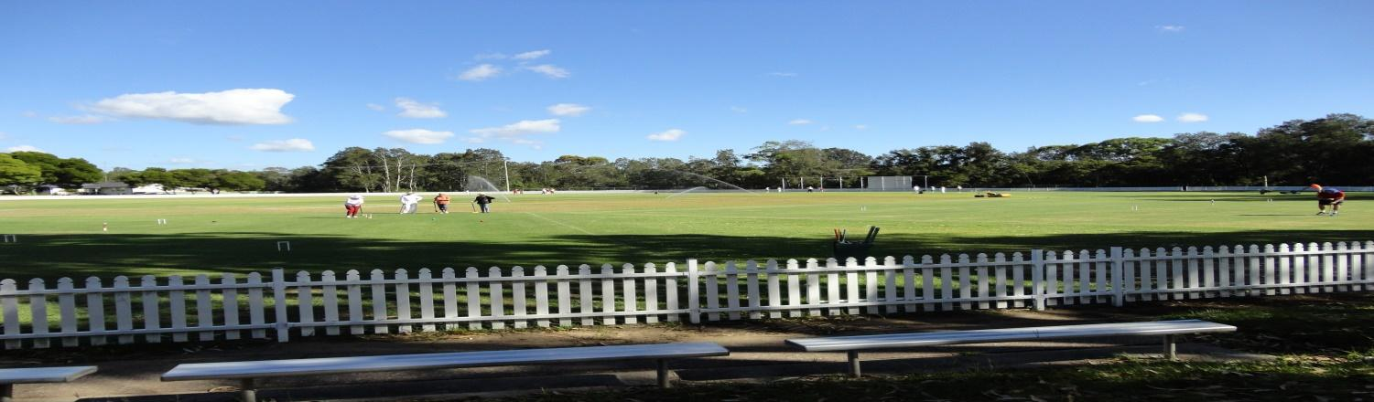
Toronto Croquet Club Inc.
GC Doubles Gala
To be held at Ron Hill Oval, Toronto.
Level Play in Block
Wednesday 22/05/19 $20 per player
Closing date for applications: Wednesday 1/05/19
Lunches can be ordered
Tea/Coffee etc. provided
Entries may be restricted to 3 pairs from each club
Entries accepted in strict order with payment
Wednesday- 8.00 am Registration, 8.30amGames commence.
Contact
Ruth Mulvaney – 0438 583 622
Players may nominate in pairs, or singly and be partnered with someone

Toronto has an extreme weather policy that will be displayed.

TORONTO DOUBLES GALA ENTRY FORM
DATE: 22/05/19
name |  | partner name
address |  | address
email |  | email
phone |  | phone
club |  | club
Handicap |  | Handicap
Index |  | Index
Fee$ |  | Fee$

FEES PAYABLE
Name | Partner
TOTAL

Please forward registration form to torontocroquetclub@yahoo.com.au
if payment made by direct debit to
BSB: 650 000 Account No 529 487 701. (Please include GALA + surname & initial)

OR Post to: Tournament Secretary, PO Box 369 TORONTO 2283
With cheque made payable to Toronto Croquet Club

Please note late withdrawals, may not be entitled to a refund of entry fee.

