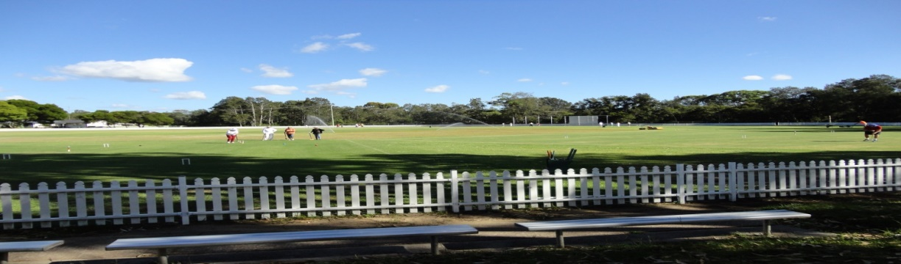
Toronto Croquet Club Inc
Presents our
SPRING TOURNAMENT
At Ron Hill Oval, Toronto
GOLF CROQUET DOUBLES

Tuesday 15th/ Wednesday 16th October, 2019
ENTRY FEE- $30 per person
Contact
Ruth Mulvaney – 0438 583 622
Closing Dates for entries: 24th, September, 2019

Registration 8:00 Play starts 8:30 for each competition day
Morning and afternoon teas included. Lunches can be purchased each day.
Format: Level play in seeded block play. Handicap cards will be used.
Players may nominate in pairs, or singly and be partnered with someone.
A limit of 6 players per club may be applied.
SPRING TOURNAMENT ENTRY FORM
Please use this entry form

name |  |  | partner name
address |  |  | address
email |  |  | email
phone |  |  | phone
club |  |  | club
Handicap |  |  | Handicap
Index |  |  | Index
Able to referee |  | Y/N | Able to referee |  | Y/N
(please circle)
Fees payable
name | partner
TOTAL

Please forward registration form to torontocroquetclub@yahoo.com.au
if payment made by direct debit to
BSB: 650 000 Account No 529 487 701. (Please title - ST, surname & initial)

OR Post to: Tournament Secretary, PO Box 369 TORONTO 2283
With cheque made payable to Toronto Croquet Club

Please note late withdrawals, may not be entitled to a refund of entry fee.

