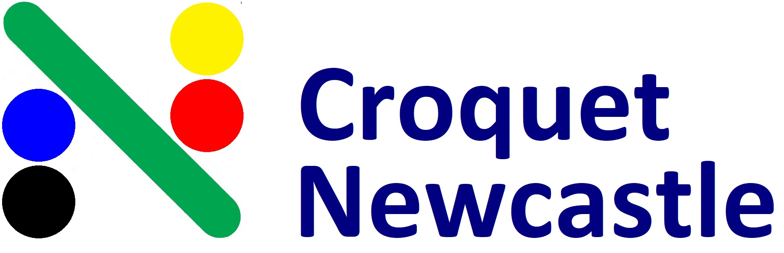
___________________________________________________________________________________

Golf Croquet Carnival
3rd & 4th July 2021
___________________________________________________________________________________

DOUBLES: Saturday 3rd July – LEVEL Play (8am start)
Sunday 4th July – HANDICAP Play (8am start)
___________________________________________________________________________________

Entry Fees: $30/person.
Morning and Afternoon teas will be provided and lunches on Sat and Sun are available for purchase at clubhouse.
___________________________________________________________________________________

Entries and payment by 25th June 2021. Please email your names, phone numbers, email address, club and handicap to: croquetnewcastle@gmail.com with the subject line: “GC Carnival Entry”. Direct Debit: BSB 650000 A/C No. 952962418 Ref: GC + your surname OR mail with cheque (payable to Newcastle National Park Croquet Club Inc) by 25th June to: Secretary, PO Box 2052, Dangar, NSW, 2309.
(a $10 processing fee will be deducted if a refund cheque is required)

Tournament Manager – Jan Tiedeman 0409 459151 Games Captain – Derek Bull 0417 565475
Newcastle National Park Croquet Club - 25 National Park Street, Newcastle West, NSW, 2302
__________________________________________________________________________________

