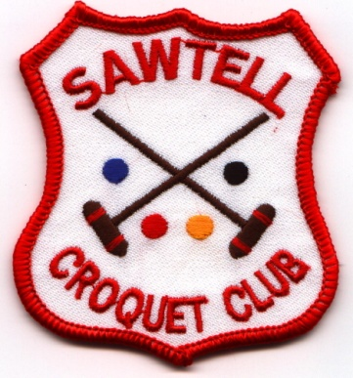
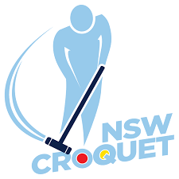
CNSW
RICOCHET OPEN DOUBLES
Hosted by Sawtell Croquet Club
Thursday 24 June and Friday 25 June 2021
Entry fee - $30 per player
Entries close 10 June 2021
- Entries accepted strictly in order of receipt of entry and payment
- 2 hour games, 26 points, stop on the bell, level play
- Entrants may have to play 3 games each day
- Rules of Ricochet, August 2019 edition
- CNSW AC Tournament Regulations

Register: Online at croquet-nsw.org

Tea, coffee and light refreshments provided
Lunch can be bought each day
Tournament dinner at Sawtell RSL Club Friday evening

Entrants can register and practice from 2.00pm Wednesday 23 June 2021

Enquiries
Jenny Arnold: email sawtellcroquet13@gmail.com; mobile 0411197452
Richard Hughes: email ricochet@croquet-nsw.org; mobile 0428 864 920

