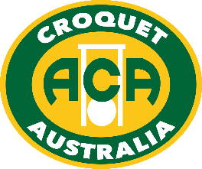

2021 Australian Golf Croquet
Handicap Doubles and Singles

Australia's major GC handicap event is in Albury
Monday 27th Sept to Friday 1st October 2021
Dates may vary slightly depending upon the number of entries.
- Doubles - Monday 27 to Tuesday 28 Sept
- Singles - Wednesday 29 Sept to Friday 1 October

This will be the second year that these events are held at Albury, after covid-19 cancelled 2020, and we’re keen to build on the success of 2019. Talk to your friends and other members of your Club; get a group together and encourage them to enter one of Australia’s most enjoyable national competitions.

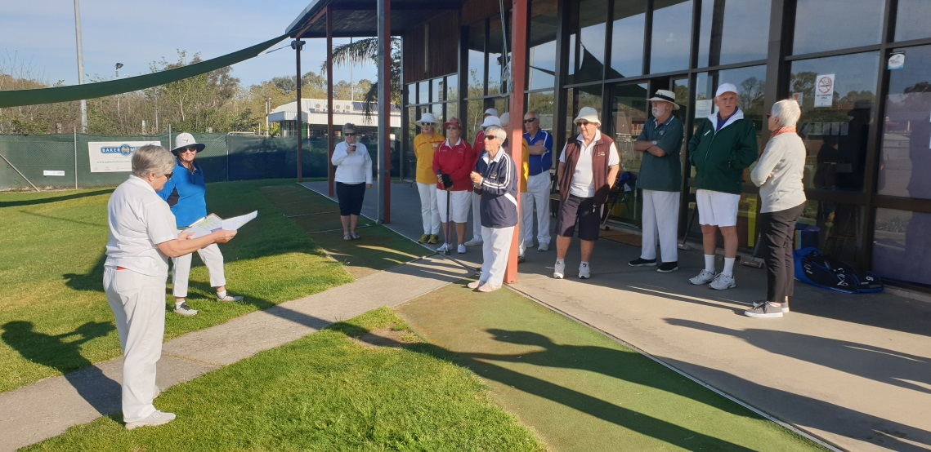

You can enter on-line via the Croquet Australia website, for both Singles & Doubles.
You can nominate your own Doubles partner, or enter by yourself and ask for a partner.
Entries will be listed in this event on croquetscores (after April 2021).

If confused or have a query, just email events@croquet-australia.com.au.
Entries close midnight Thursday 9 September 2021 (WA time)

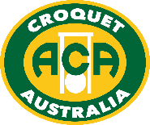

www.croquet-australia.com.au

Tournament Manager: Sarina Cevaal-Hewitt
Tournament Referee: TBC
Tournament Handicapper: Peter Freer
ACA Events: Peter Freer
Headquarters: Twin City Croquet Club, at the Albury Tennis Association,
365 Townsend Street, South Albury (8 courts – more if required).
Entries: on-line via ACA website
https://croquet-australia.com.au/gc-handicap-singles/
https://croquet-australia.com.au/gc-handicap-doubles/
Closing Date for Entry: Thursday 9 September 2021
Entry fees: Doubles: $60 per player
Singles: $90 per player
Full time students (under 25) and players aged under 21 at 31 December 2021 are entitled to 50% reduction of the above fees.

Hoops: Both Quadway and cast iron hoops may be used, set to 3 ¾”.

Functions: Informal Barbeque: Sunday 26 September at 6.00pm.
Tournament Presentation after each final.
Tournament Dinner Friday 1 Oct, if enough demand.
Practice: By arrangement with organisers from noon Sunday 26 Sept,
and Tuesday if this does not interfere with the Doubles Final
Accommodation: Contact the organisers for advice on
twincitycroquetclub@gmail.com
Catering: Tea & coffee; snacks & lunches available for purchase
Events
- Australian Golf Croquet Handicap Doubles (Holders: Barry Jennings & Stephen Condous)
27-28 Sept. Entries are limited to 32 pairs in order of receipt. Players will be allocated a partner if entering without one. We expect play to commence in seeded blocks (up to 8 pairs per block). Qualifying pairs will be re-seeded for the knock out phase. Matches are single 13-point games except for knock-outs which will be best-of-3 if time permits. Matches will start untimed, but the manager may impose a time limit if necessary. There will be no plate event for pairs eliminated from the knock-out.
- Australian Golf Croquet Handicap Singles (Holder: Kate McLoughlin)
29 Sept - 1 Oct. Entries are limited to 64 players in order of receipt. Depending on entries we expect play to commence in seeded blocks (up to 8 players per block). Qualifying players will be re-seeded for the knock-out phase. Matches will be single 13-point games except that knock-outs will be best-of-3 if time allows. Players are expected to play up to 6 games and/or 7 rounds per day. Matches will start untimed, but the manager may impose a time limit if necessary. A plate will be held for players eliminated from the knock-out.
Conditions – the WCF 2018 GC Rules will be used. Detailed conditions are in the ACA Tournament Regulations & will be in the Event Program.
Tournament Regulation 26 - Handicapping
These tournaments are important in providing information about relative handicaps between States.
The Tournament Handicapper will be pro-active in correcting players’ handicaps during the events, where there are discrepancies between players’ ability and their current handicap.

