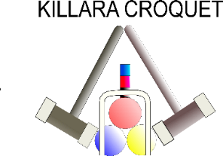

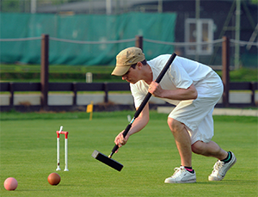
CNSW
AC
BRONZE SINGLES
CHAMPIONSHIP
Monday April 11th – Thursday April 14th
^{(It may be played over 3 days)}
This event will be hosted by and held at
KILLARA CROQUET CLUB

Open to handicaps 14-20
18 point games
Ordinary level play
- Games will be double-banked
Starting time each day will be advised when the number of entries is known.

Entries to CNSW by 1st April, 2022 by registering on the Events 2022 page of the website (www.croquet-nsw.org)

Enquiries to the Tournament Manager, Susan Howland
killarasec@gmail.com

