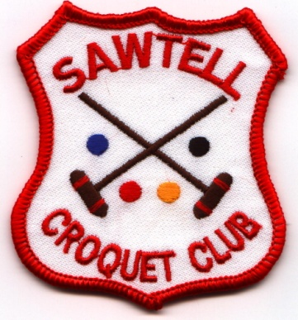
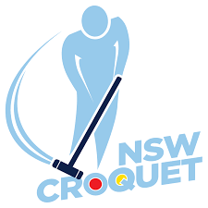
CNSW
RICOCHET OPEN SINGLES
Hosted by Sawtell Croquet Club
Monday 27th, Tuesday 28th, Wednesday 29Th June 2022
Entry fee - $50 per player
Entries close 10 June 2021
- Entries accepted strictly in order of receipt of entry and payment
- 2 hour games, 26 points, stop on the bell, level play
- Entrants may have to play 3 games each day
- Rules of Ricochet, August 2019 edition
- CNSW AC Tournament Regulations

Register: Online at croquet-nsw.org

Tea, coffee and light refreshments provided
Lunch can be bought each day
Tournament dinner at Sawtell RSL Club Sunday evening

Enquiries
Jenny Arnold: email sawtellcroquet13@gmail.com; mobile 0411197452
Richard Hughes: email ricochet@croquet-nsw.org; mobile 0428 864 920

