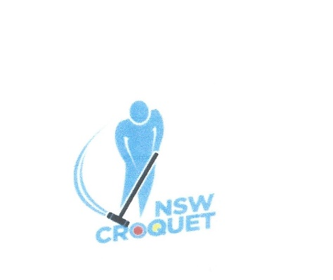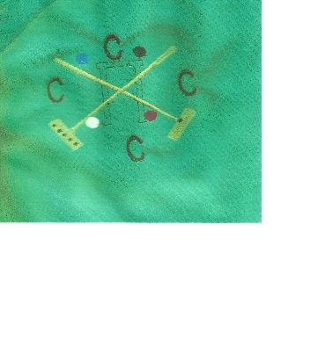
CNSW
Association Croquet 9 and over Handicap Singles
(with base bisques = 6)
Monday – Wednesday 7 - 9 November 2022
Hosted by Coutts Crossing Croquet Club

Entry Fee: $50 per entry
Entries close – 28 October 2022
Sunday 6th November : collect programs and practise between noon and 4pm

Tournament Manager/Secretary: Peter Martin
By email : petermartin2460@gmail.com or phone 0438 999 204

Tea, coffee and light refreshments provided
Lunches may be purchased
Tournament Dinner: details to be advised
Registrations are now available on-line via CNSW (croquet-nsw.org)

