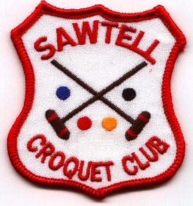
4 DAYS OF GOLF CROQUET
SAWTELL CROQUET CLUB Inc.
4 days of GC AT SAWTELL
GOLF CROQUET

Friday 5th to Monday 8th AUGUST 2022
Double Round Robin – Level and Handicap play
BLOCK PLAY
3 COURTS

International Balls.

Entry Fee $50 per player.
(Entries restricted to up to 6 members from any one Club and will be accepted in strict order of payment.)

(Includes Morning/Afternoon Tea and Finger Food at Presentation)
Light Luncheon available at the clubhouse.

ENTER NOW
Entries Close 27th July 2022

Tournament Secretary, P.O. Box 86 SAWTELL NSW 2452
Phone: Jenny Arnold 0411197452
Email sawtellcroquet13@gmail.com

ENTRY FORM
SAWTELL CROQUET CLUB Inc. - 4 days of Golf Croquet
August 5 – 9, 2022
NAME ___________________________________________________

ADDRESS _____________________________________________________

PHONE _____________ EMAIL ___________________________________

HANDICAP ____ INDEX _______ (Please advise of any change before the event)

CLUB________________________________________ ACA ID No ______

Please enclose your entry fee of $50.
EMAIL: sawtellcroquet13@gmail.com
Payment to BSB 533 000 account No 32829679
Post to: Tournament Secretary,
P.O. Box 86, SAWTELL NSW 2452
Phone: Jenny Arnold - 0411197452

ENTRY FORM
SAWTELL CROQUET CLUB Inc. - 4 days of Golf Croquet
August 5 – 9, 2022
NAME ___________________________________________________

ADDRESS _____________________________________________________

PHONE _____________ EMAIL ___________________________________

HANDICAP ____ INDEX _______ (Please advise of any change before the event)

CLUB________________________________________ ACA ID No ______

Please enclose your entry fee of $50.
EMAIL: sawtellcroquet13@gmail.com
Payment to BSB 533 000 account No 32829679
Post to: Tournament Secretary,
P.O. Box 86, SAWTELL NSW 2452
Phone: Jenny Arnold - 0411197452

