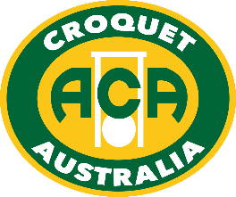

2022 Australian Golf Croquet
Handicap Doubles & Singles

Australia's major GC handicap event is in Albury
Monday 26th to Friday 30th September 2022
Dates may vary slightly depending upon the number of entries.
- Doubles - Monday 26 to Tuesday 27 Sept
- Singles - Wed 28 to Friday 30 Sept

This will be the second year that these events are held at Albury, after covid-19 cancelled 2020 & 2021, and we’re keen to build on the success of 2019. Talk to your friends and other members of your Club; get a group together and encourage them to enter one of Australia’s most enjoyable national competitions.

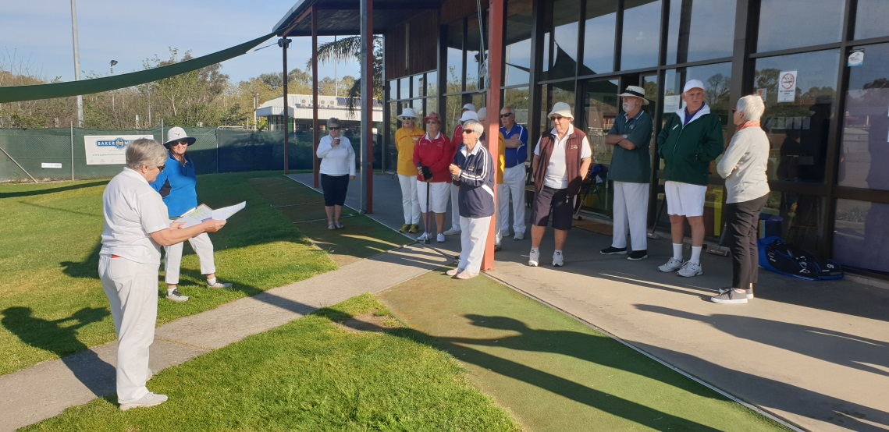

You can enter on-line via the Croquet Australia website, for both Singles & Doubles.
You can nominate your own Doubles partner, or enter by yourself and ask for a partner.
Existing entries are listed in these events on croquetscores
https://croquetscores.com/2022/gc/aust-handicap-doubles-champs
https://croquetscores.com/2022/gc/australia-handicap-singles

If confused or have a query, just email events@croquet-australia.com.au.
Entries close midnight Thursday 8 September 2022 (WA time)

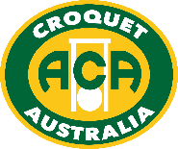

www.croquet-australia.com.au

Tournament Manager: Sarina Cevaal-Hewitt
Tournament Referee: Jim Clement
Tournament Handicapper: Peter Freer
ACA Events: Peter Freer
Headquarters: Twin City Croquet Club, at the Albury Tennis Association,
365 Townsend Street, South Albury (8 courts – more if required).
Entries: on-line via ACA website
https://croquet-australia.com.au/gc-handicap-singles/
https://croquet-australia.com.au/gc-handicap-doubles/
If you get an error message, do not enter again or you’ll pay twice
– just contact Peter Freer at pfreer@netspeed.com.au
Closing Date for Entry: Thursday 8 September 2022
Entry fees: Doubles: $60 per player
Singles: $90 per player
Full time students (under 25) and players aged under 21 at 31 December 2021 are entitled to 50% reduction of the above fees.

Hoops: Both Quadway and cast iron hoops may be used, set to 3 ¾”.

Functions: Informal Barbeque: Sunday 25 September at 6.00pm.
Tournament Presentation after each final.
Tournament Dinner Friday 30 Sept, if enough demand.
Practice: By arrangement with organisers from noon Sunday 25 Sept,
and Tuesday if this does not interfere with the Doubles Final
Accommodation: Contact the organisers for advice on
twincitycroquetclub@gmail.com
Catering: Tea & coffee free; snacks & lunches available for purchase
Events
- Australian Golf Croquet Handicap Doubles (Holders: Barry Jennings & Stephen Condous)
26-27 Sept. Entries are limited to 32 pairs in order of receipt. Players will be allocated a partner if entering without one. We expect play to commence in seeded blocks (up to 8 pairs per block). Qualifying pairs will be re-seeded for the knock out phase. Matches are single 13-point games except for knock-outs which will be best-of-3 if time permits. Matches will start untimed, but the manager may impose a time limit if necessary. There will be no plate event for pairs eliminated from the knock-out.
- Australian Golf Croquet Handicap Singles (Holder: Kate McLoughlin)
28-30 Sept. Entries are limited to 64 players in order of receipt. Depending on entries we expect play to commence in seeded blocks (up to 8 players per block). Qualifying players will be re-seeded for the knock-out phase. Matches will be single 13-point games except that knock-outs will be best-of-3 if time allows. Players are expected to play up to 6 games and/or 7 rounds per day. Matches will start untimed, but the manager may impose a time limit if necessary. A plate will be held for players eliminated from the knock-out.

Conditions – the WCF 2022 GC Rules will be used, but we are using Extra Strokes not Advantage Play. Detailed conditions are in the ACA Tournament Regulations & will be in the Event Program.

