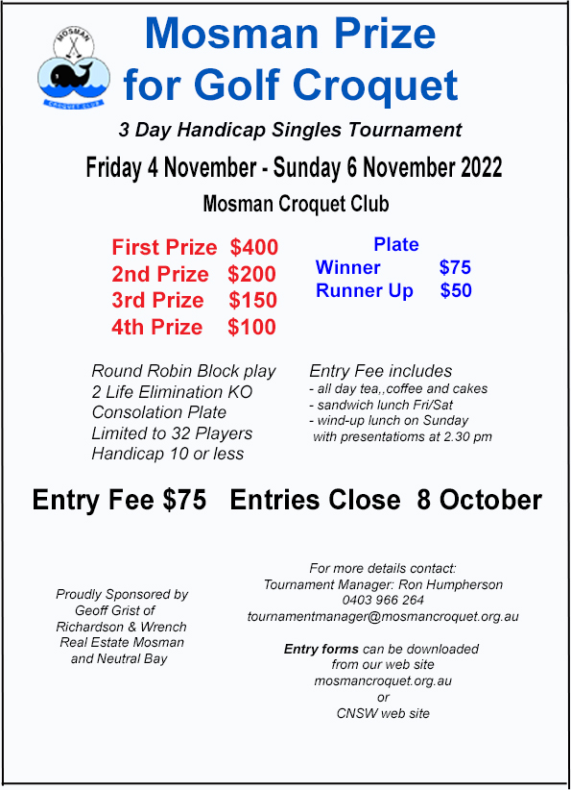

ENTRY FORM
The Mosman Prize for Golf Croquet
4 November - 6 november 2022

entries close: 8 October 2022

PLAYER Information
Name:
Club: | Handicap: |  |  | Refereeing?: Yes No
Home Telephone: |  |  | Mobile:
E-mail:
Postal Address (if no email address):

FEES
Entry fee includes: all day tea/coffee and cakes, sandwich lunch Fri/Sat, wind-up lunch on Sunday. Visitors welcome for Sunday lunch: Cost $20
Entry fee: |  |  |  |  | $75
Visitor’s Sunday lunch @ $20 |  | No of visitors |  |  | $
Total |  |  |  |  | $

PAYMENT INFORMATION
Online: Post:

Pay by direct deposit:  PLEASE NOTE NEW BANKING DETAILS:  Bendigo Bank Mosman  BSB 633-000  Account No. 146453774  Reference: PRIZE “your name”  Send a copy of this form by email to: tournamentmanager@mosmancroquet.org.au |  |  | Write your cheque payable to:  Mosman Croquet Club.  Send to:  Tournament Manager,  The Mosman Prize for Golf Croquet  Mosman Croquet Club,  Alexander Ave, MOSMAN, 2088

for more information

Tournament Manager: Ron Humpherson Tel: 0403 966 264

Mosman Croquet Club Website: www.mosmancroquet.org.au

