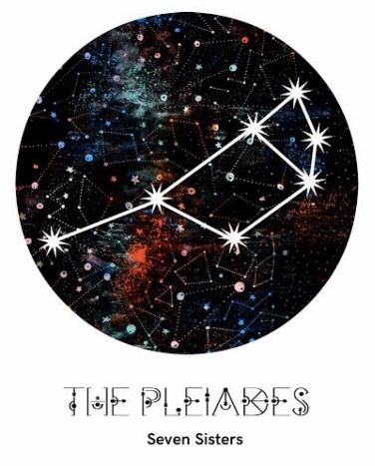
  - MAKARA SEASON!

Seven Sisters

Dreaming

AC Handicap Singles

ENTRY FORM

Association Handicap Singles
26 point singles handicap play (no lifts)
Tues 6 to Thurs 8 Sept at Cooks River Club, Tempe.
Entry fee $30 per person
Entries close 20/8/22
ENTRY DETAILS
NAME
CLUB
ACA ID
HANDICAP
EMAIL
PHONE
Are you willing to referee?

All payments via EFT to
MAKARA CROQUET CARNIVAL
BSB: 082-184 A/C#: 840951642
(Please make sure your surname is in the reference field)

Email Entry and Copy of EFT Receipt to: lorralyn@optusnet.com.au

