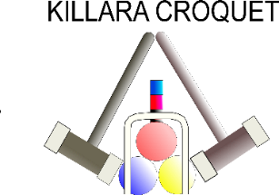
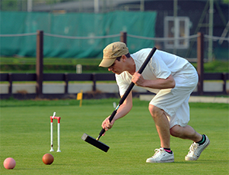

CNSW
AC
BRONZE SINGLES
CHAMPIONSHIP
R

To be played at Killara Croquet Club
Open to handicaps 14-20
18 point games
Ordinary level play
Games will be double-banked

PLEASE ENTER BY REGISTERING
on the Events 2023 page of the CNSW website
www.croquet-nsw.org
on or before 31 March 2023

Enquiries to the Tournament Manager, Susan Howland
killarasec@gmail.com

