NSW 9 & Over AC Handicap Singles
at Canberra Croquet Club
Coronation Drive, Yarralumla ACT
Monday 6 – Wednesday 8 November 2023
Entry Requirements
Open to all with a 9 or higher AC bisque – Entry Fee $50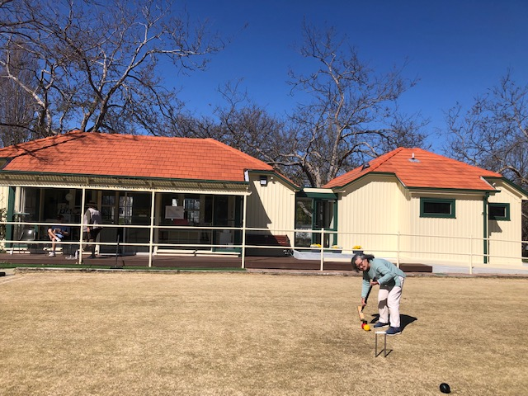
Format: This competition will be handicap singles played as full bisque, with a base handicap of 6. (refer Laws of Association Croquet Appendix 3)
Refer CNSW Tournament Regulations for conditions of play.
https://www.croquet-nsw.org/governance/policy/CNSW-Tournament-Regulations.pdf
Coffee and tea will be provided, along with biscuits for morning and afternoon tea.
Lunches will be available for purchase.
Closing Date for Entries: 27 October 2023
Registrations are now available on-line
(https://www.croquet-nsw.org/events)
Accommodation options listed on Canberra Croquet Club website https://canberracroquet.org.au/about/accommodation
For more information contact Club Captain Ralph Richardson

