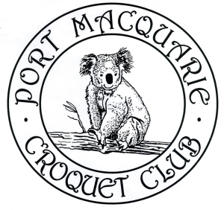
PORT MACQUARIE CROQUET CLUB Inc.
invites you to their
67th Annual Association Croquet Carnival
on the Buller Street courts, Port Macquarie.

Monday 24 July to Friday 28 July 2023
5-day Singles Tournament
Entry fee: $60 per person

- Welcome 3:00pm Sunday 23 July
- Practice allowed from 1:00pm until 3:30pm on Sunday 23 July
- Round Robin tournament run under current Regulations
- Format to be determined by the Carnival Committee - dependent on number of entrants
- Games to be double banked
- Entrants may be required to play 2 games on the same day
- Morning and afternoon tea will be available
- Soup, together with a roll, will be available for lunch
- Entry fee includes presentation function at the end of the Carnival on Friday 28 July

Entries to:

Tournament Secretary Bridget Earle

Email (preferred): bridget@earles-paradise.com

Mail: Port Macquarie Croquet Club
15 Buller Street
Port Macquarie NSW 2444

Phone: 0412 923 232

Tournament Manager Sue Moss

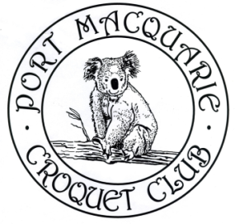
Email: susanmoss1607@gmail.com

Phone: 6584 5497

PORT MACQUARIE CROQUET CLUB Inc.
67th Annual Association Croquet Carnival
Monday 24 July to Friday 28 July 2023

ENTRY FORM

Name
ACA ID Number
Address
Mobile Phone
Email address
Club
Handicap
Index

Are you willing to referee? Yes/No (if Yes, how many times .......)

EITHER (preferred) email your entry form to:
bridget@earles-paradise.com

OR Post your entry form to:
Tournament Secretary
Port Macquarie Croquet Club
15 Buller Street
Port Macquarie NSW 2444

Pay the entry fee of $60 by bank transfer or bank deposit to:

BSB: 032 586
Account Number: 249 968
Reference: Surname followed by Initials

