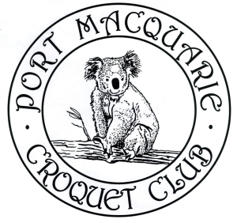
PORT MACQUARIE CROQUET CLUB Inc.

Golf Croquet Carnival

on the Buller Street courts, Port Macquarie.

Wednesday 6 September to Friday 8 September 2023
3 - day Level and Handicap Singles Tournament
Entry fee: $50 per person

Individual Entries limited to 6 per club – no group bookings

- Welcome - 3:00pm Tuesday 5 September
- Practice - 1:00pm until 3:30pm on Tuesday 5 September
- Round Robin tournament run under current Regulations
- Games to be double banked
- Morning and afternoon tea will be available
- Sandwiches will be available for lunch
- Entry fee includes presentation function at the end of the Carnival on Friday 8 September

Entries to:

Tournament Secretary Bridget Earle

Email (preferred): bridget@earles-paradise.com

Mail: Port Macquarie Croquet Club
15 Buller Street
Port Macquarie NSW 2444

Phone: 0412 923 232

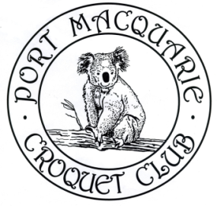
Tournament Manager Jill Drury

Email: jillbirdy@gmail.com

Phone: 0408 381 195

PORT MACQUARIE CROQUET CLUB Inc.
Golf Croquet Carnival
Wednesday 6 September to Friday 8 September 2023

ENTRY FORM

Name
ACA ID Number
Address
Mobile Phone
Email address
Club
Handicap
Index

Are you willing to referee or act as scorer/timekeeper? Yes/No

EITHER (preferred) email your entry form to:
bridget@earles-paradise.com

OR Post your entry form to:
Tournament Secretary
Port Macquarie Croquet Club
15 Buller Street
Port Macquarie NSW 2444

Pay the entry fee of $50 by bank transfer or bank deposit to:

BSB: 032 586
Account Number: 249 968
Reference: Surname followed by Initials

