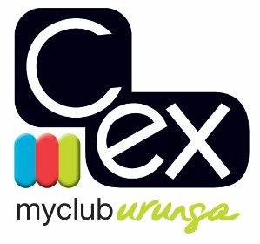

URUNGA CROQUET CLUB

12th ANNUAL GOLF CROQUET SINGLES CARNIVAL

Tuesday 17th to Friday 20th October 2023

Round Robin Event with Level and Handicap Play

ENTRY FEE: $60.00

Entries restricted to up to 6 members from any one Club and will be accepted on the basis of the first received with payment.

Practice from 1 PM Monday

All entries to:

October GC Carnival Secretary
C.ex Urunga Croquet Club
PO Box 95
Urunga
NSW 2455

OR
Email to
geoffjchapman@yahoo.com

C.ex URUNGA CROQUET CLUB

ENTRY FORM for Golf Croquet Singles Carnival

Tuesday 17^{h} to Friday 20th October 2023

Name:
Address:
Phone No:
Mobile No:
Email Address:
ACA ID
Club
Golf Croquet Handicap
Index

Are you willing to assist with refereeing? YES/NO

Are you a qualified Golf Croquet Referee? YES/NO

Entries restricted to up to 6 members from any one Club and will be accepted in strict order of payment.

Cost: $60.00

All entries to: October GC Carnival Secretary Electronic Payment:
Urunga Croquet Club Account Name: Urunga Croquet Club
PO Box 95 BSB: 533-000
Urunga Account Number: 50338
NSW 2455 Details: Surname GC Oct

Or

Email entry with payment receipt number to- geoffjchapman@yahoo.com

