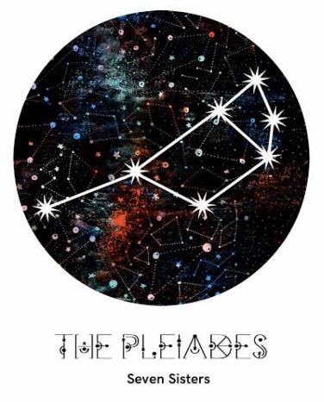
MAKARA SEASON 2023
Seven Sisters
Dreaming

ASSOCIATION Handicap Singles

ENTRY FORM
1st-3rd August 2023 at Cooks River Club, Tempe.
Submit entries to:
Makaracroquet@gmail.com by Thursday 20th July 2023
Entry fee $30 per person
ENTRY DETAILS
NAME
CLUB
ACA ID
HANDICAP
EMAIL
PHONE
Are you willing to referee?
All payments via EFT to:
MAKARA CROQUET CARNIVAL
BSB: 082-184 A/C#: 840951642
(Please make sure your surname is in the reference field)

PRESENTATION of AWARDS
The presentation of awards for all events in MAKARA 2023
will take place on November 22, 2023
at Cooks River Croquet Club, Mackey Park, Tempe
commencing at 3pm

