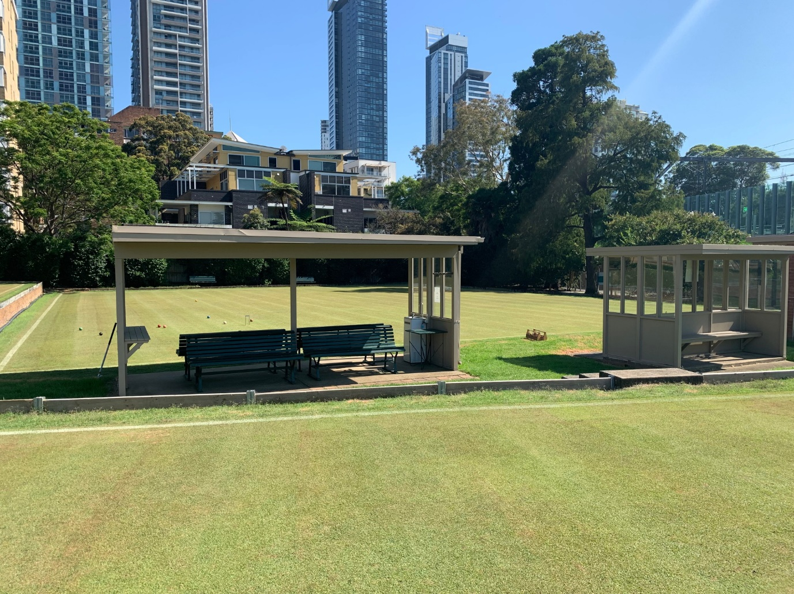
CROQUET NSW

ASSOCIATION CROQUET
PLATINUM BROOCH SINGLES CHAMPIONSHIP

Monday 2 – Tuesday 3 September 2024
Chatswood Croquet Club
699A Pacific Highway Chatswood

Open to handicaps 0 to 2.5
26 point games - advanced play
Starting time 8am

Entries to CNSW by 23 August, 2024
Register on Events 2024 page at www.croquet-nsw.org
Enquiries Ted Woodley (Tournament Manager) 0419 663 539

