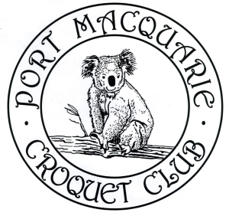
PORT MACQUARIE CROQUET CLUB Inc.
invites you to their
68th Annual Association Croquet Carnival
on the Buller Street courts, Port Macquarie.

Monday 29 July to Friday 2 August 2024
5-day Singles Tournament
Entry fee: $60 per person

- Welcome 3:00pm Sunday 28 July
- Practice allowed from 1:00pm until 3:30pm on Sunday 28 July
- Round Robin tournament run under current Regulations
- Format to be determined by the Carnival Committee - dependent on number of entrants
- Games to be double banked
- Entrants may be required to play 2 games on the same day
- Morning and afternoon tea will be available
- Lunch will be available
- Entry fee includes presentation function at the end of the Carnival on Friday 2 August

Entries to:

Tournament Secretary Bridget Earle

Email (preferred): bridget@earles-paradise.com

Mail: Port Macquarie Croquet Club
15 Buller Street
Port Macquarie NSW 2444

Phone: 0412 923 232

Tournament Manager Sue Moss

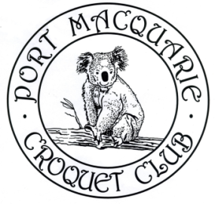
Email: susanmoss1607@gmail.com

Phone: 6584 5497

PORT MACQUARIE CROQUET CLUB Inc.
68th Annual Association Croquet Carnival
Monday 29 July to Friday 2 August 2024

ENTRY FORM

Name
ACA ID Number
Address
Mobile Phone
Email address
Club
Handicap
Index

Are you willing to referee? Yes/No (if Yes, how many times .......)

EITHER (preferred) email your entry form to:
bridget@earles-paradise.com

OR Post your entry form to:
Tournament Secretary
Port Macquarie Croquet Club
15 Buller Street
Port Macquarie NSW 2444

Pay the entry fee of $60 by bank transfer or bank deposit to:

BSB: 032 586
Account Number: 249 968
Reference: Surname followed by Initials

