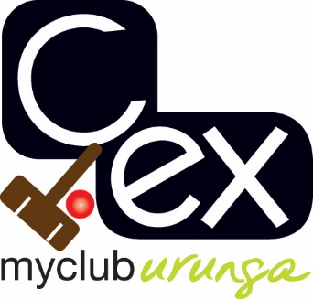

URUNGA CROQUET CLUB

33RD Annual association CARNIVAL

17th to 21ST JUNE 2024

Format for 2024 to be determined closer to event and is dependent on entry numbers.

HANDICAP RANGE 0 - 20

ENTRY FEE - $60 includes morning and afternoon teas and finger food at presentation.

ENQUIRIES TO:

Tournament Manager:

Barb Piggott
042 762 9953
urungacroquetclub@gmail.com

c.ex URUNGA CROQUET CLUB

ASSOCIATION CARNIVAL

17 – 21 JUNE 2024

Name:
Address:
Phone No:
Mobile No:
Email:
Club
AHS Handicap

Are you willing to assist with refereeing? YES / NO

Cost: $60.00

All entries to: Association Carnival Secretary Electronic Payment:
Urunga Croquet Club Account Name: Urunga Croquet Club
PO Box 95 BSB: 533-000
Urunga Account Number: 32800640
NSW 2455 Details: Surname AC Jun

